Table of Contents

1 Introduction...................................................................................................

2 New Features of Spark AR  
...................................................................................................................  
2 Downloading the Data Files  
....................................................................................................................  
2 Starting Spark AR  
..............................................................................................................................  
2 Opening Files in Spark AR  
..................................................................................................................  
2 Navigating through Spark AR  
............................................................................................................

### 3Workspace Overview .................................................................................................................... 5 Scene Panels .................................................................................................................................. 6 Using the Scene Panel ....................................................................................................................... 6 The viewport ...................................................................................................................... 7 Editing objects in the Viewport .............................................................................................................. 7 The Simulator ................................................................................

### 9 The Assets panel ............................................................................................................. 10 The Inspector .................................................................................................................. 10 The Toolbar and Menu bar ................................................................................................................... 11 The Menu bar ...................................................................................................................... 11 The Layers panel **............................................................................................................................** **14** Using the Layers Panel .................................................................................................................................. 14 Layers Panel Working with Layers ...................................................................

16 The Patch Editor and Console  
............................................................................................................................17 Creating My Project  
..................................................................................................................................  
17 Conclusions  
................................................................................................................................  
Introduction

Spark AR is a studio tool from Facebook that allows users to create their own AR effect for mobile. First launched in 2017, Facebook continues to add capabilities to the platform most recently, adding in analytics for Instagram and Facebook campaigns. Compatible for mac and window the AR Platforms is comparable to the tools as sketch or Photoshop- only this augmented reality.

Spark AR enables you to create your own AR effect for mobile using a suite tools from patching to animation. What’s more you don’t have to be a technical genius to be able to use it:

* Create your own AR effect, with or without a technical background.
* Import your 3D files and sounds
* Build with or without code

New Features of Spark AR

**Facebook has added new features to Spark AR, including target tracking, which allows AR effects to be anchored to specific images or objects in the real word, and Native Slider, a new optional controller that can be called up directly in the Instagram app that lets users pick and make fine adjustments to an effect. Additionally, the team are releasing an update to**[**Spark AR Studio (v76)**](https://sparkar.facebook.com/ar-studio/download/)**that introduces a variety of new features that help simplify and streamline the creation of AR effects. This update includes templates, a new feature that helps jumpstart the creation of popular AR effects, as well as actions, which provide time-saving shortcuts for common, repetitive steps in the AR creation process. For more information visit** [**https://sparkar.facebook.com/blog/introducing-new-spark-ar-studio-features-and-ar-capabilities-instagram/**](https://sparkar.facebook.com/blog/introducing-new-spark-ar-studio-features-and-ar-capabilities-instagram/)

**Downloading the Data Files**The Spark AR data file can be download, at <https://sparkar.facebook.com/ar-studio/>. It is recommended to save the data files on your desktop for easy access.

**Starting Spark AR**The following steps cover how to start Spark AR using Window computer or mac OS. The steps for starting the program on other computers may vary.

**To start spark AR studio in Windows 10:**1. Click the **Start** button, click **All apps**, and then click **Spark AR studio**.

**Opening files in Spark AR studio.**

Spark AR Studio Supports various file formats, depending on the type of object or asset you’re importing. Once the desired file has been imported to a computer, you can open it in Spark AR Studio for further viewing and editing.  
**To open a file in Spark AR Studio:**1. Click the **File** menu, and then click **Open**.  
2. In the **Open** dialog box, navigate to the **Data Files** folder, select any desiredfile, and then click the **Open** button.  
3. Repeat steps 1 and 2 to open

**Navigating through Spark AR Studio**

The best way to become familiar and comfortable with any workspace is to explore and practice. Furthermore, learning to maneuver through Spark AR studio will give you a head start when learning how to use the workspace.

**Workspace Overview**

The work area, or workspace, includes menus, toolbars, and panels that give you quick access to an array of tools and options for editing, manipulating and creating filters. The default workspace in Spark AR studio displays the **Menu** and **Options** bars at the top of the window, the **Tools** panel on the left side of the window, and several other panels on the right side of the window.

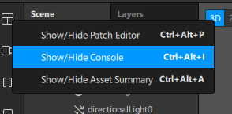

### The Scene panel

Adding objects to the Scene panel at the left of the interface will add them to your effect.

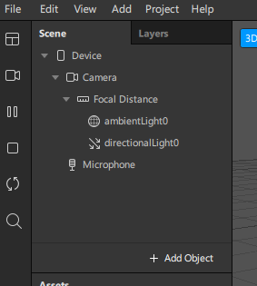

Click **Add Object** to add an object. You'll see a list of all the different objects included in Spark AR Studio. You can also select **3D Object** to import an object from your computer.

This is also where you'd insert an element that will make your effect respond to the person using it, or someone's environment. For example [a face tracker](https://sparkar.facebook.com/ar-studio/learn/documentation/articles/people-tracking/face-tracker) if you want to build an effect that responds to someone's face.

You can create relationships between objects in the Scene panel. Creating a child-parent relationship means you can make the same change to multiple objects at the same time, by making a change to the parent object. To create a child-parent relationship, drag the object that you want to be the child onto the object that you want to be the parent.

The viewport

When the **Camera** is selected in the menu on the left of the screen, blue lines will appear. These lines show where the camera is pointing and which objects are in view of the camera.

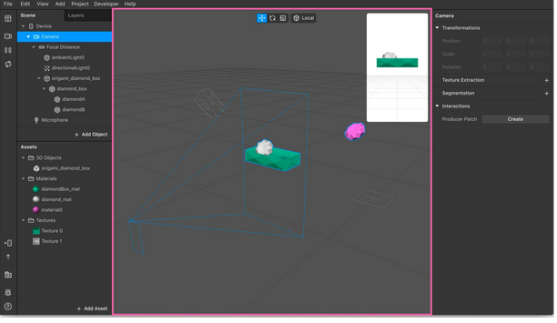

When an object is listed underneath the **Camera** in the Scene panel, it will move with these blue lines - because it's in camera space. You can test this out by clicking and dragging your mouse in the Simulator.

When an object isn't listed under the camera, it's in what's known as 'world space'. It won't move with these lines, and can be placed in a fixed position in the world. Read more about [world effects](https://sparkar.facebook.com/ar-studio/learn/documentation/articles/world-effects/world-effects-introduction).

At the top of the Viewport are [the Manipulators](https://sparkar.facebook.com/ar-studio/learn/documentation/articles/3D/using-the-manipulators). Use them to quickly change your object's:

* **Position** - to choose where your object is placed within your scene.
* **Scale** - to make your object appear bigger or smaller.
* **Rotation** - to rotate your object.

**Editing objects in the Viewport**

3D and 2D objects can be edited in the Viewport. You can change their position, scale and rotation. The default setting is for editing 3D objects. To switch to 2D, click the 2D button in the top right corner:

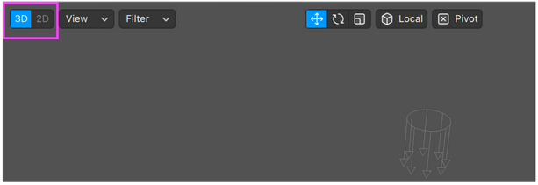

When this option is:

* Set to 3D, you can [edit 3D objects.](https://sparkar.facebook.com/ar-studio/learn/articles/3D/using-the-manipulators)
* Set to 2D, you can [edit 2D objects](https://sparkar.facebook.com/ar-studio/learn/articles/2d/2d-editor).

### The Simulator

The Simulator represents a device screen. For example, a mobile or a tablet:

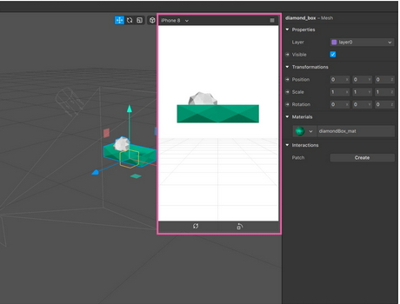

Use it to preview how your effect will look, including with different compression settings. Find out more about [using the Simulator](https://sparkar.facebook.com/ar-studio/learn/documentation/articles/fundamentals/the-simulator).

### The Assets panel

This is where you can add your own assets to a project or create assets in Spark AR Studio.

Click **Add Assets** to create assets or add your own. You can add textures, materials, 3D models, animations and audio files here.

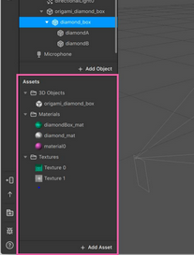

### The Inspector

Use the Inspector to make all kinds of changes assets and objects. You'll need to select the asset or object in the Scene panel or Assets panel first.

Below, we've selected one of the mesh that makes up the 3D object in our scene:

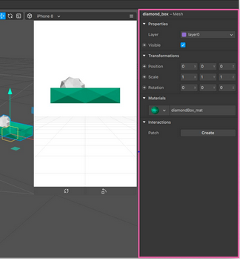

We could use the Inspector to change:

* Which layer it's on, by adjusting the dropdown next to **Layer**.
* Whether or not it's visible in the scene, by checking the box next to **Visibile**.
* Its position, scale and rotation, by changing the **X**, **Y** and **X** values under **Transformations**.
* Its material, by clicking the dropdown under **Material**.

We could also click **Create**, next to **Patch**. This will create a patch representing the mesh [in the Patch Editor](https://sparkar.facebook.com/ar-studio/learn/documentation/patch-editor/using-the-patch%20editor).

Some properties have arrows next them. This means a patch can be created to represent the property.

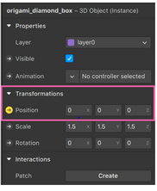

So if we click the arrow next to **Position**, a patch would be added representing the position of the mesh. You could connect this patch to other patches in a graph, to manipulate the position of the mesh.

### The Toolbar and Menu bar

**The Toolbar**

The toolbar is along the left of the interface. Click the icons to:

* Configure your workspace, for example to show or hide the Patch Editor.
* Change the video playing in the Viewport.
* Pause or restart the video.
* Stop the video. Stopping the video, or pausing and restarting the video, resets your effect to its initial state. Any changes you make when the effect is stopped will be applied when you press play.
* Test your effect on a device.
* Export your effect.
* Report a bug.

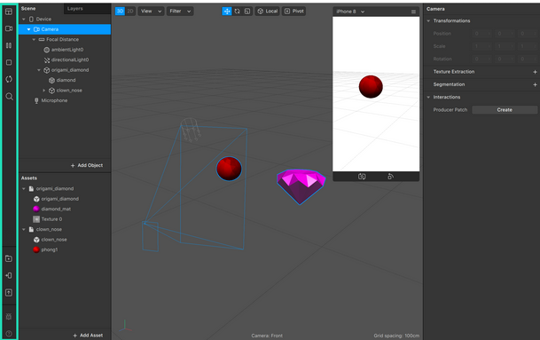

**The Menu bar**

You can access a number of shortcuts and features through the menu bar along the top of the screen. For example, under:

* **File** you'll find options to save or export your project
* **Edit** you can undo and redo actions.
* **View** you can configure your workspace.
* **Insert** you can add objects and assets to your project.

### The Layers panel

Use this panel to create layers. Find out [more about using layers in your effects](https://sparkar.facebook.com/ar-studio/learn/documentation/articles/fundamentals/layers).

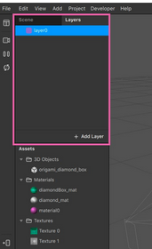

**Using the Layers Panel** Each layer includes multiple components such as  
layer visibility, layer title, layer/vector mask thumbnail (if applicable), layer  
thumbnail, and layer effects (if applicable). Layers can be created, restacked, moved, deleted, and duplicated.  
**Figure 22 – Layers Panel Working with Layers** Layers determine the order in which objects are displayed. Furthermore, only the currently active or selected layer can be edited. The following steps introduce the basics of working with layers such as naming, moving, creating, or deleting a layer.  
**To name or rename a layer:**1. Open the **practicing with layers** file.  
2. In the **Layers** panel, click the eye icon next to each layer to determine what object is located on that layer (see Figure 23). **NOTE**: Another method for determining what object is located on a specific layer is to right-click that layer’s eye icon, and then click  
**Show/Hide all other layers** on the shortcut menu.  
3. Double-click the **Layer 3** layer title, type **Post Office**, and then press the **Enter** key.  
4. Repeat step 3 to rename **Layer 4** to **Person**.

### The Patch Editor and Console

Use the [Patch Editor](https://sparkar.facebook.com/ar-studio/learn/documentation/tutorials/patch-editor/) to create effects with logic, animation and interactivity, without using scripting. Use the Console to [add JavaScript](https://sparkar.facebook.com/ar-studio/learn/documentation/tutorials/scripting/) to your project.

To open or close the Patch Editor or console, click to **View** in the menu bar and select either:

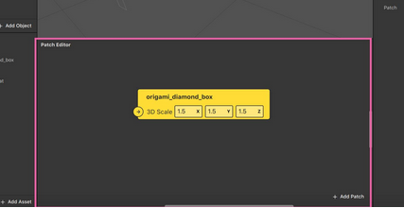

* **Show/Hide Patch Editor.**
* **Show/Hide Console.**

Both the Patch Editor and Console will open at the bottom of the screen:

Creating a Glass Filter

**To start spark AR studio in Windows.**1. Click the **Start** button, click **all apps**, and then click **Spark AR studio**.

2. Create a new blank Project.

3. The preview window.

4. Click on the camera Icon, to choose a Simulation or click the Face time HD camera to use yourself for preview.

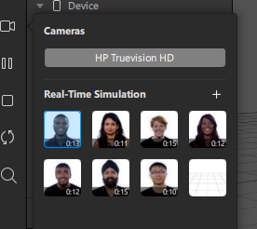

5. You can change the size of the preview window by clicking the simulation, Use it to preview how your effect will look, including with different compression settings.

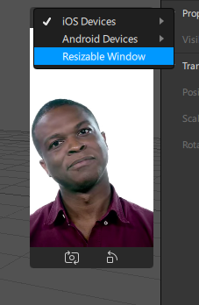

6. Click on add object then add a facemesh. You can see the facemesh shown below.

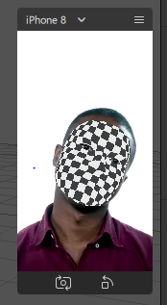

7. Go to scene panel and click on the facemesh to add material. Where you can change color to the facemesh.

8. At the button left click on add Asset.

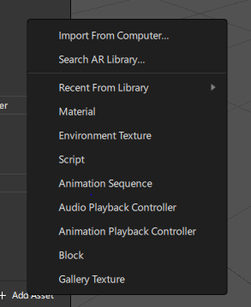

9. Then click import from AR library or search AR Library.

10. The next window that popup it’s a 3D model from sketch Fab. You can search or scroll to select the model (search for Glasses).

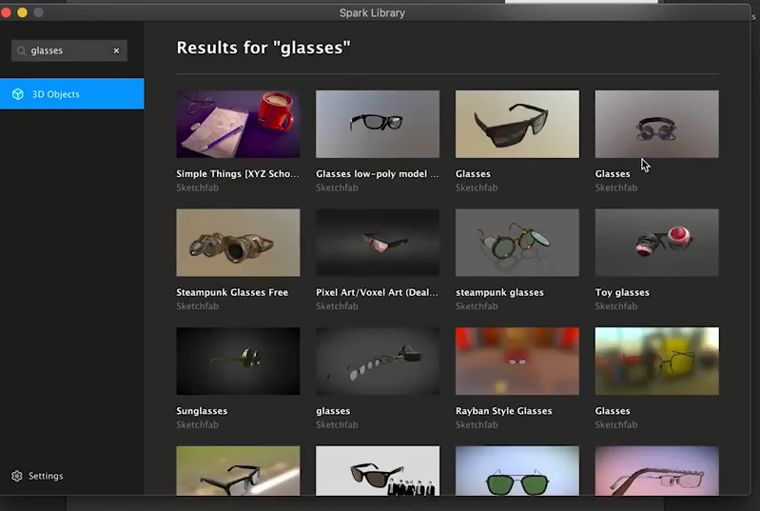

11. Select and click download model to import the glasses.

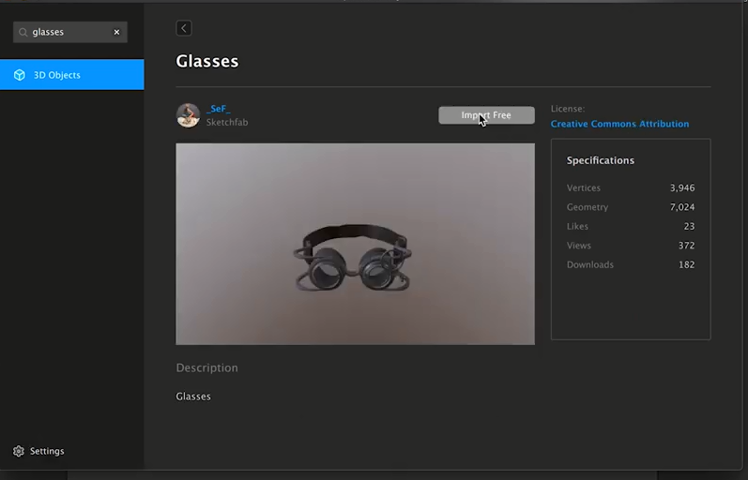

12. Click and drag to where the facemesh is located at the scene panel.

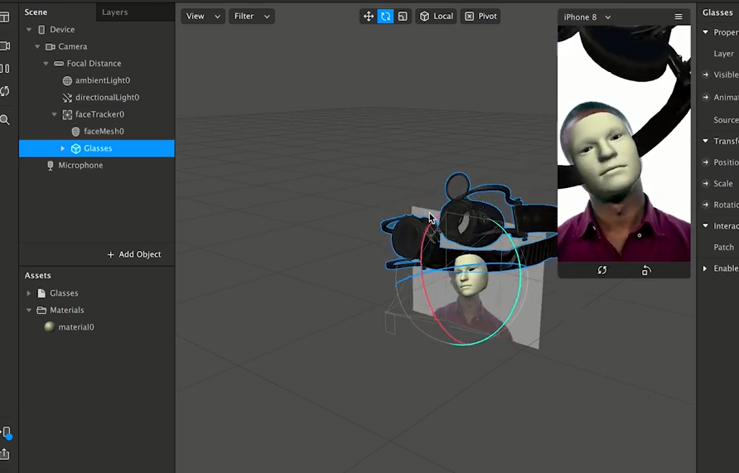

13. To resize and fit inn to the simulation click pause to resize and adjust the glass model.

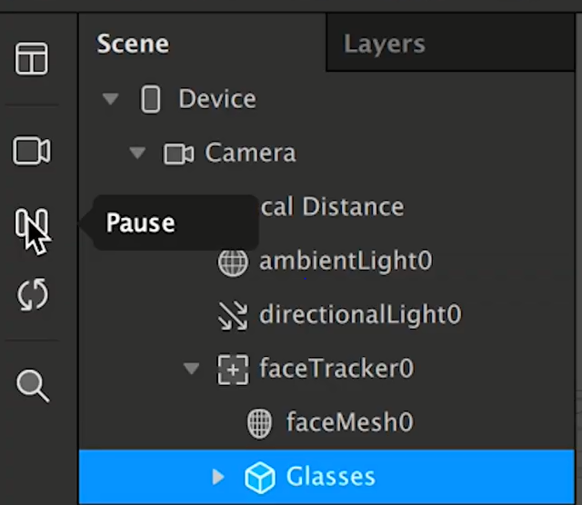

14. Click on the glasses from the scene panel and the inspection panel appears, Use the Inspector to make all kinds of changes assets and objects.

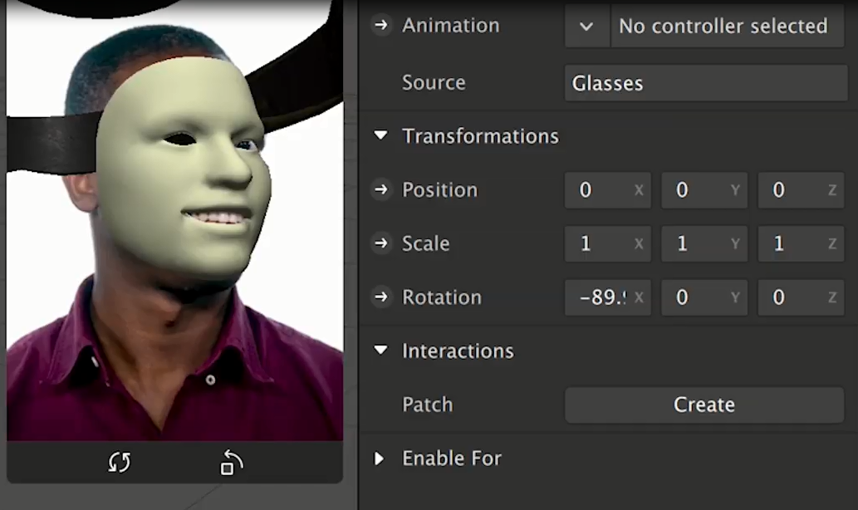

15.You’ll see the inspection, panel click and adjust the transformation setting eg, (position, scale and Rotation).

16. You can clink and type in the values or you can click from the top edit the scale of the selected object or objects.

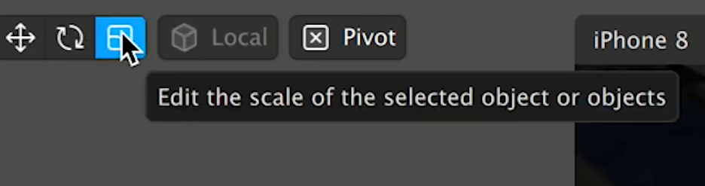

17. From the viewport you’ll see the glasses object selected and ready for transformation.

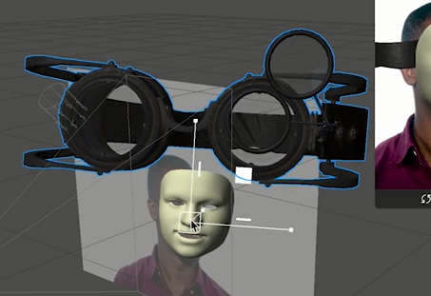

18. To Change the Position, and Rotation click on the move icon at the middle top of the studio or insert the values at the inspection panel.

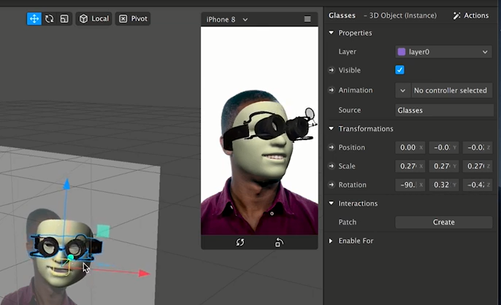

To preview without the facemesh.

19. Click on the material from the Asset panel to change material opacity to 0.

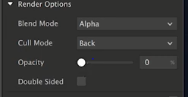

* You can resize the facemesh occlude more or less.

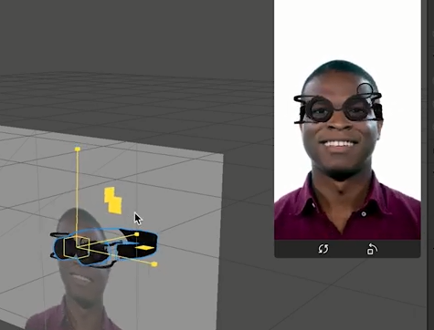

20. Then save the project, click on file from the top left of the Spark AR studio and click on save

21. To test, click on the test on device at the bottom left.

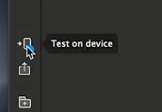

22. You can upload it on the Spark AR Hub.

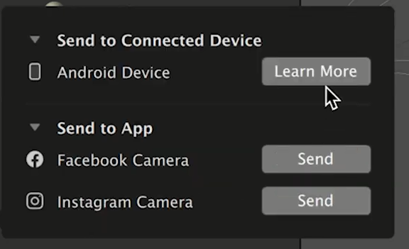

**Conclusion** *During this introduction to Spark AR you have learned a wealth of information. You are now adept at navigating through the menus, tool bar, and tool options bar. You also have a practical knowledge of some of the tools within each group. Now you will be able to navigate through Spark AR comfortably. However, Spark AR has an endless list of tools, and it would be impossible to teach you everything in Spark AR, which is why we encourage you to explore Spark AR while working or in your spare time!*